

Banana Keyboard

# Introduction

In this lesson, we will create our own music instrument using banana and orange.

# Necessarry:

* micro:bit, battery holder and 2 AAA batteries
* Banana
* Orange
* Crocodile clips

# Process!

1. Connect the ground lead

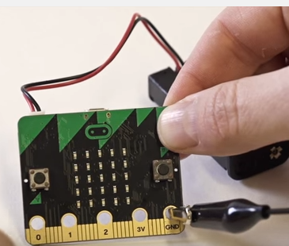

1. Connect the sound lead

Using the **2nd** crocodile clip, connect the end of the crocodile clip onto pin **0** of the micro:bit

1. Connect the headphone to ground

Using the **1st** crocodile clip, connect the second end of the crocodile clip onto based of the headphone jack.

1. Connect the headphone sound contact

Using the 2nd crocodile clip, connect the second end of the crocodile clip onto tip of the headphone jack.

1. Connect a fruit lead

Using the 3rd crocodile clip, connect the end of the crocodile clip onto the 1st crocodile clip already clipped onto GND.

1. Connect the orange to ground

Using the 3rd crocodile clip, connect the unattached end of the crocodile clip onto the orange

1. Connect a second fruit lead

Using the **4th** crocodile clip, connect the end of the crocodile clip onto pin **1** on the micro:bit.

1. Connect the banana

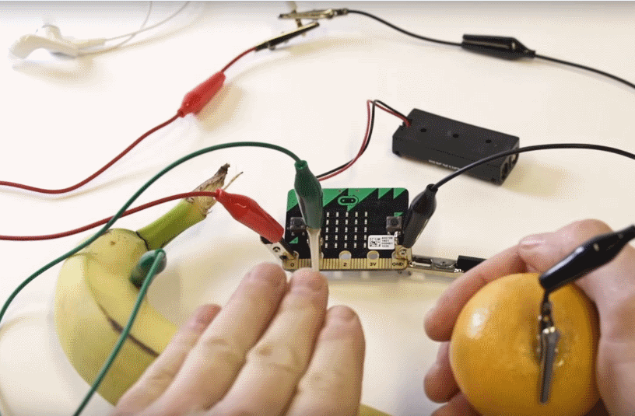

Using the 4th crocodile clip, connect the unattached end of the crocodile clip onto the banana

Your banana keyboard is ready!

1. Connect your micro:bit to your computer using your USB cable and run this script to test:

1. Let’s write full code that increases sound pitch if P1 is touched and decreases if P2 is touched. To use this, in one hand put orange and with other hand touch banana or other object of your choice that you need to connect to P2.

